I need to answer three questions about this data:
- Is location related to whether customers contacted support?

Can satisfaction score be predicted by age, loyalty level, and support contact?
- Does satisfaction score differ by customer group (A/B)?

Question 1 (Step by Step):
Is location related to whether customers contacted support?
- To answer Q1, I first ask: what is my null hypothesis and my alternative hypothesis? The null hypothesis on this question is that there will be no relationship between location and whether a person contacted support. The alternative hypothesis is that there IS a relationship between customer location and contacting support. For this question, a chi-square test would be suitable.
- Before doing any kind of tests on SPSS, I take a glance at my dataset on SPSS. I do this to see if there are any values that may need changing in excel due to their characters such as “strings” or “int” as I may run into problems running certain tests.
- Once I see I need to change some columns for this question, I load up excel and add another column called “LocationSTATE” as there were too many unique city names in my location column to run a chi-square on SPSS. I knocked those values down to just their states: CA, PA, AZ IL, NY, and TX.
- I then went back into SPSS with my new columns and clicked “analyze”, then “descriptive statistics” and opened “crosstabs”.
- I moved my new column “LocationSTATE” into the rows and my “Support_Contacted” column into the rows and clicked okay. I then click on “Statistics” and check “Chi-Square”.
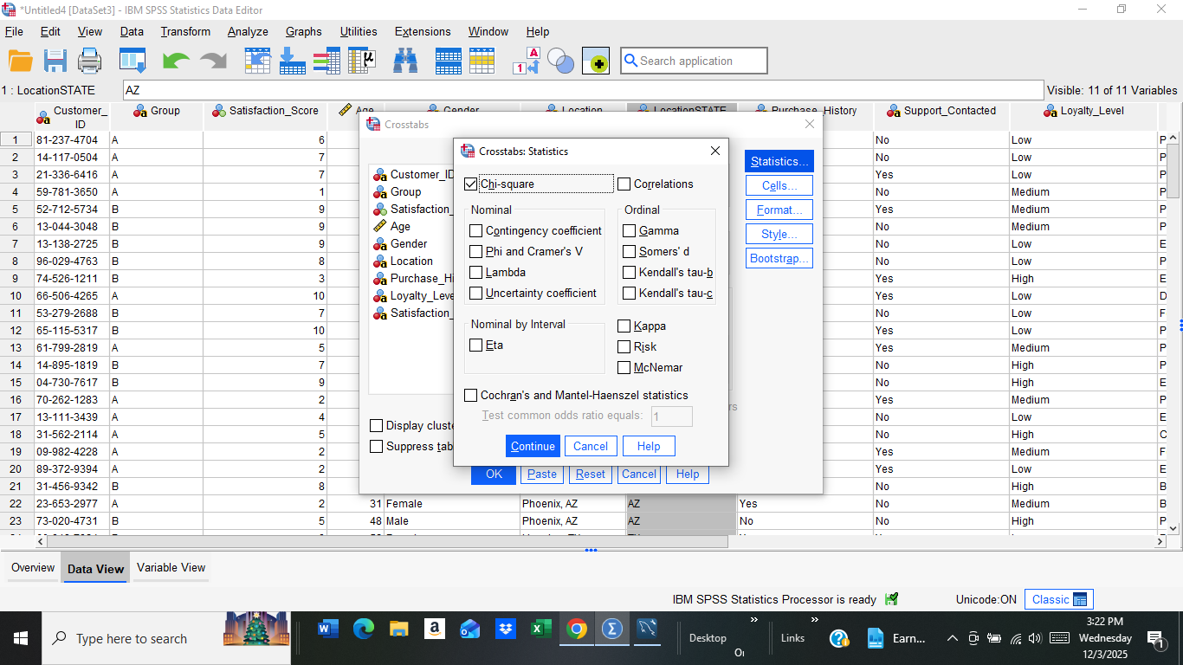
- I click “Continue” and then click on “Cells” so that I can show the observed values,expected values, row % and the column %.
- My data is loaded into a chi-square test and I can now write up my results.
- 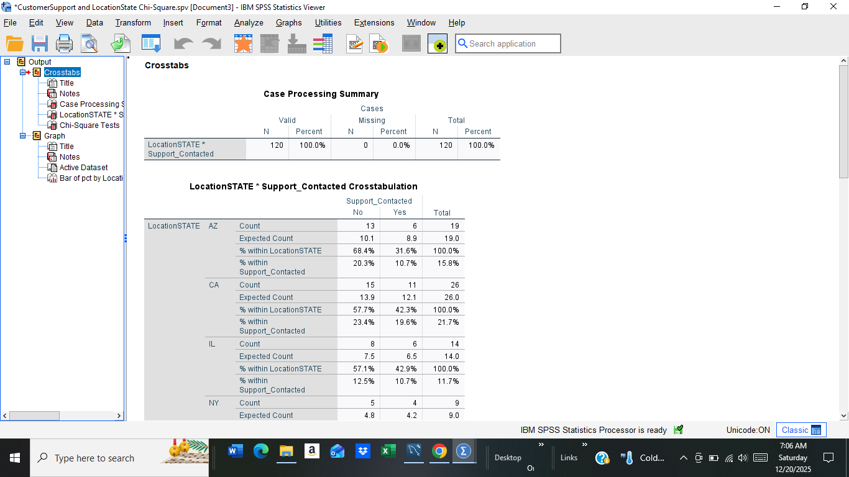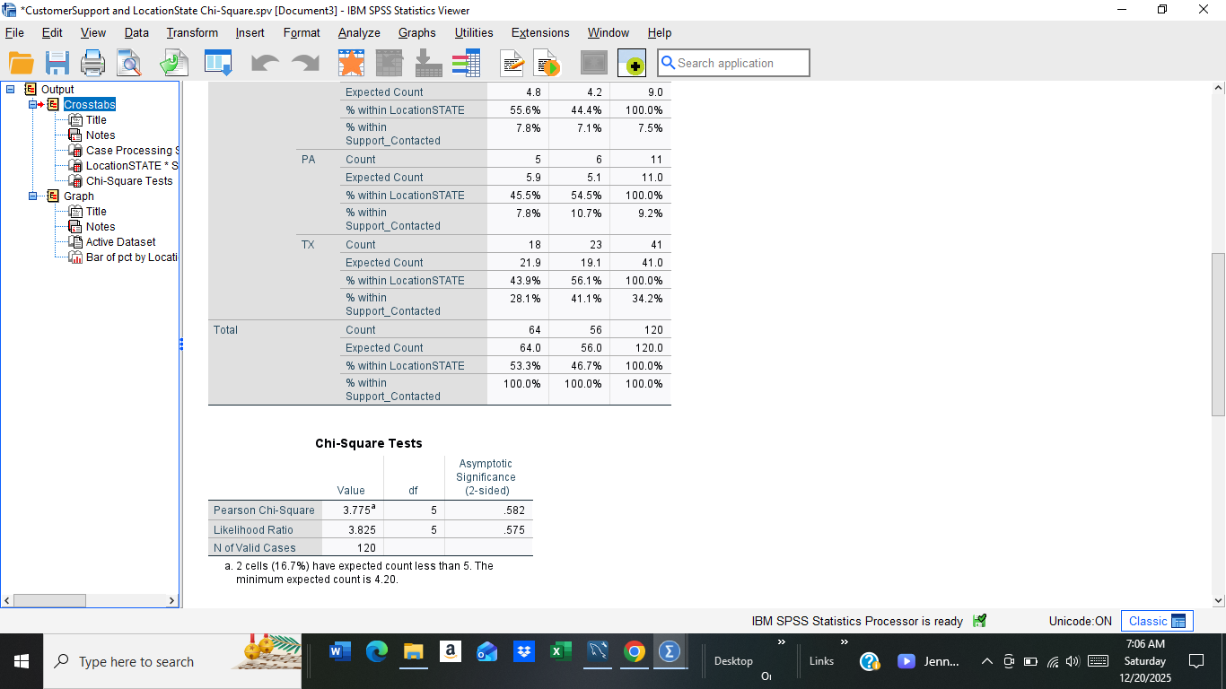
- The p-value for my results is 0.582. Since p>0.05, we fail to reject the null hypothesis. This means that there is not enough statistical evidence to show a relationship between location and the frequency of support being called.
- I then graph my data into a Simple Bar chart. 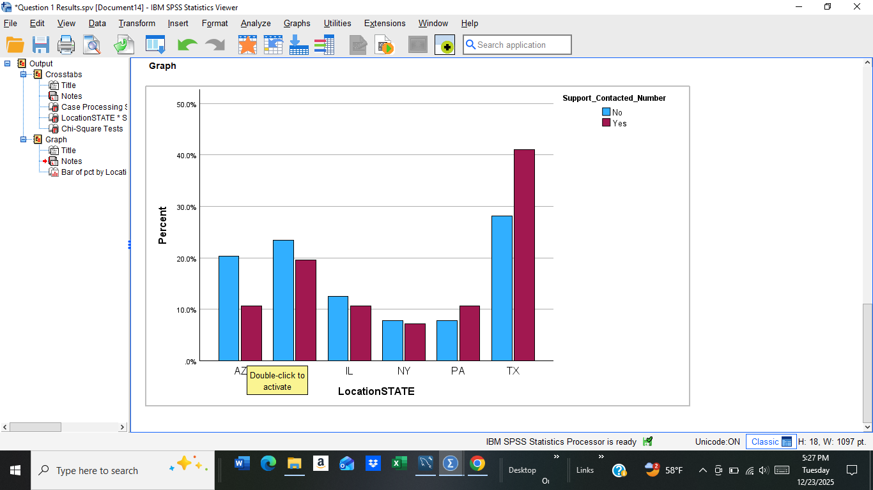

Question 2: (Step by Step)
Can satisfaction score be predicted by age, loyalty level, and if support is contact?
- I first need to make the hypotheses. The null hypothesis is that the set of predictors (age, loyalty levels and if support is contacted) will have no relationship with the satisfaction score. The alternative hypothesis is that at least one of the predictors is significantly related to the satisfaction score. I am deciding to do a multiple linear regression because I need some predictive information. On SPSS, my columns “Loyalty_Level” and “Support_Contacted” are formatted as “CHAR’s” and I can only use numeric values so I use “Automatic Recode” to transform my data into numbers.
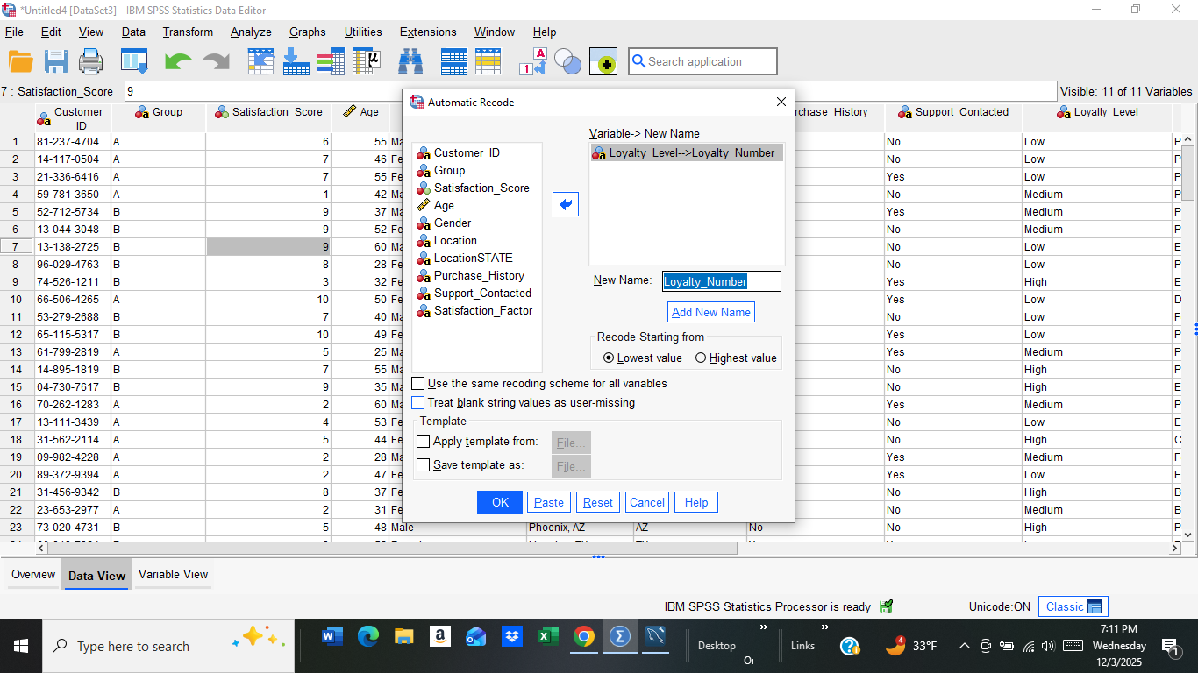


3. My new column “loyalty_number” has turned the ratings into numbers (Low = 2, Medium = 3, and High = 1). I formatted my new column “Support_Contected_Number” (Yes = 2 and No = 1) into numerical variables as well. I can then go back to formatting my linear regression.
4. My dependent variable is the satisfaction score and my independent variables are age, loyalty level and if support was called or not.
5. My results are then computed.
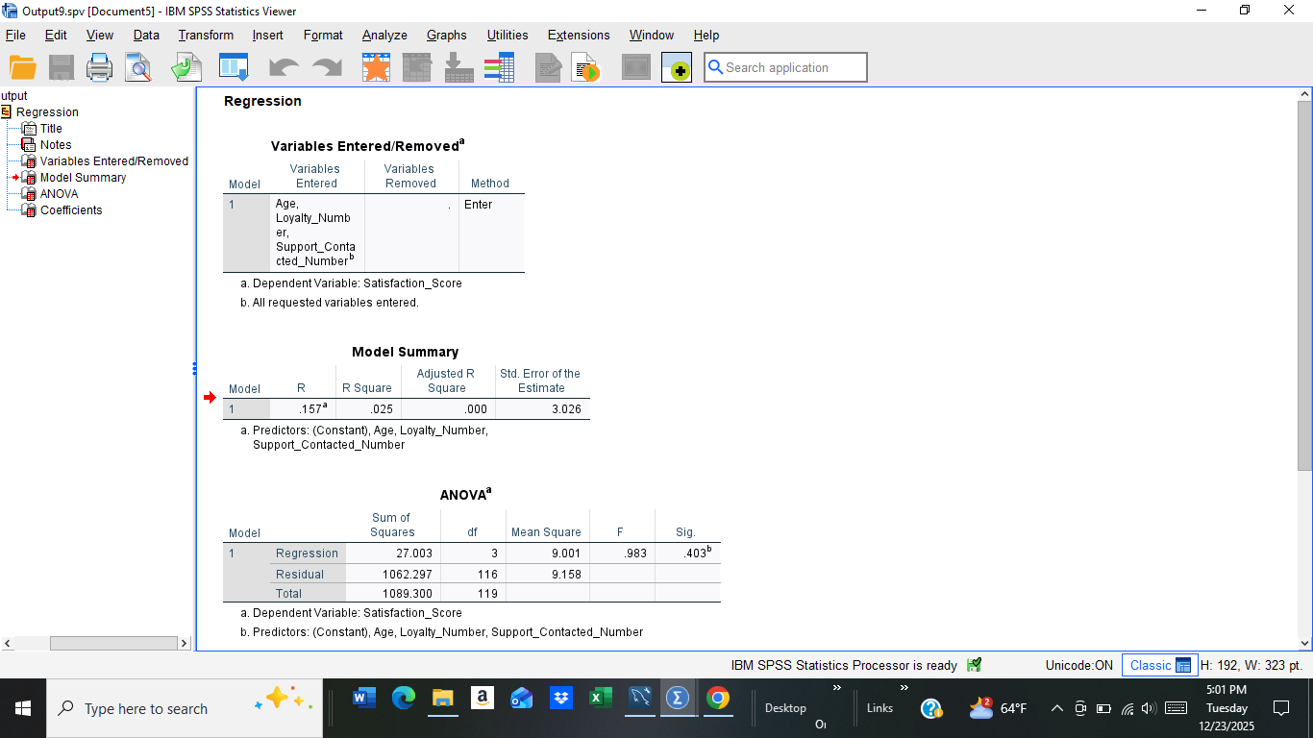
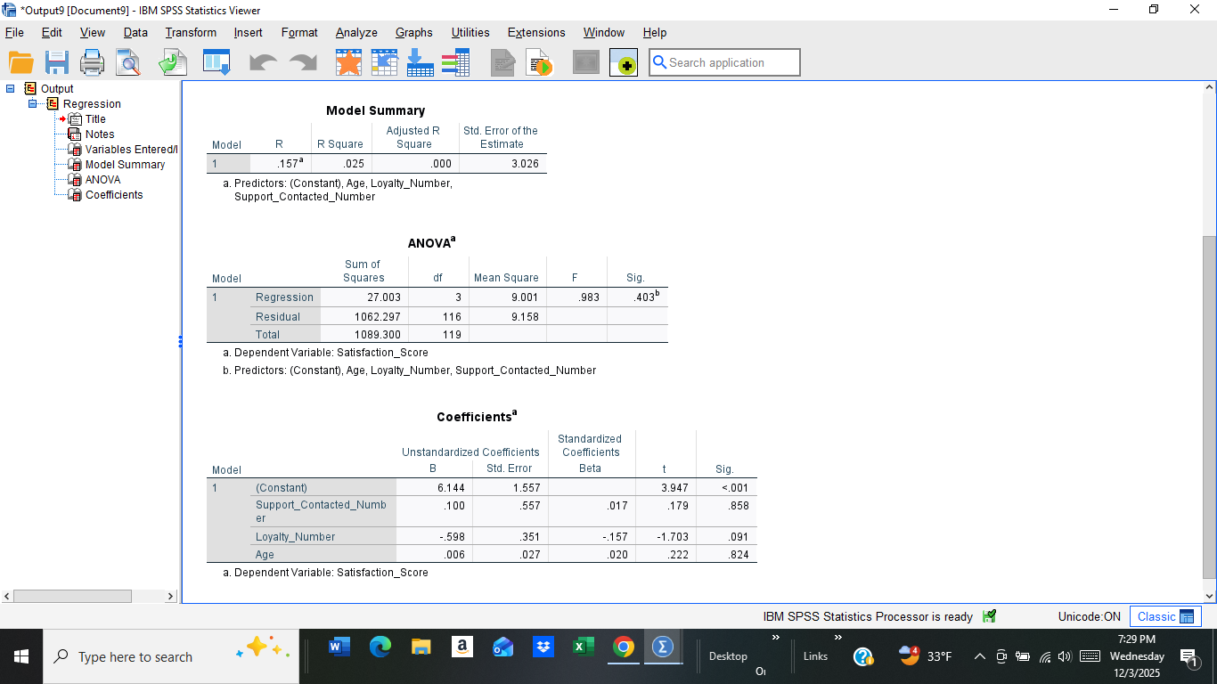

6. Overall, the regression model was not statistically significant and did not meaningfully predict satisfaction scores, F(3, 116) = 0.983, p = .403. The three factors (age, loyalty level, and whether someone contacted support) together explained only about 2.5% of the differences in satisfaction. None of the individual factors were significant on their own, meaning none of them had a strong or reliable impact on satisfaction in this dataset. We will be rejecting the null hypothesis.
7. I decide to not graph this information as there would visually be no trend to view since the data would be clustered closely together.

Question 3 (Step by Step):
Does satisfaction score differ by customer group (A/B)?
- Since I have one categorical variable with 2 groups, an independent t-test will be performed. Also, I need to state the null and alternative hypotheses. The null hypothesis is that there is no difference in satisfaction scores between Group A and Group B and the alternative hypothesis is that there is a difference in satisfaction scores between Group A and Group B.
- In SPSS, I go to “analyze”, then hover over to “compare means” then click on "independent t- test”.
- Satisfaction score is my testing variable and my groups (A and B) are my grouping variables. 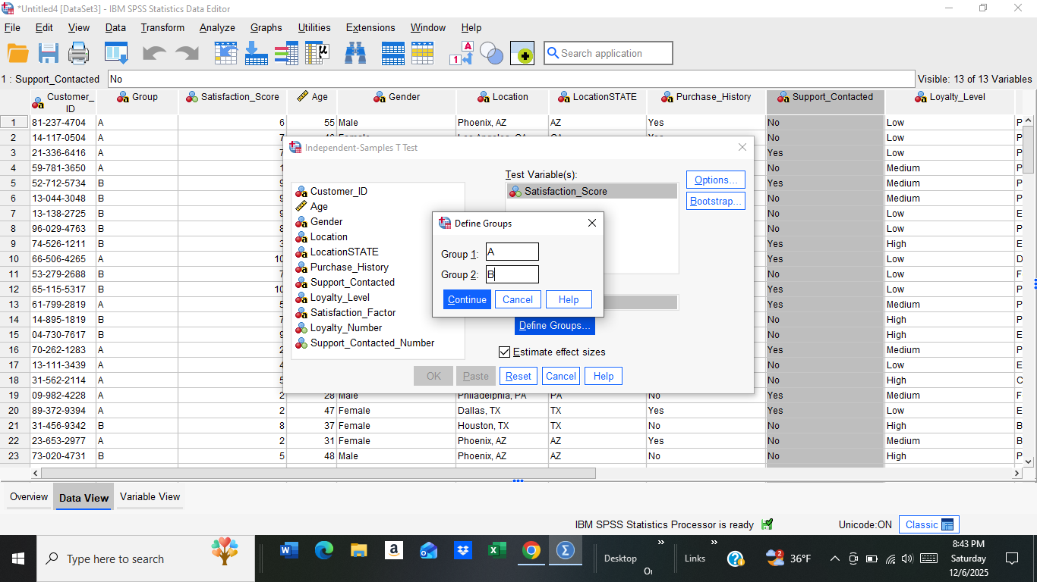
- I then run the t-test and get my results.
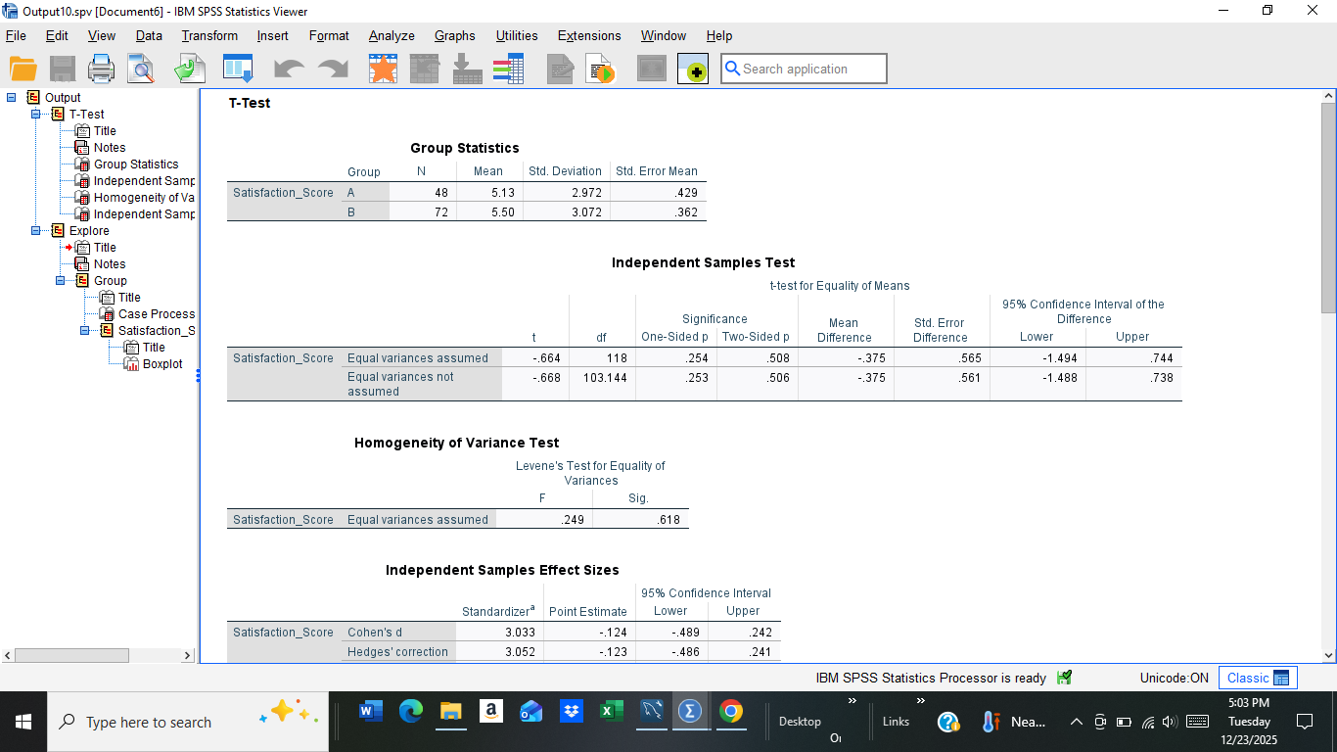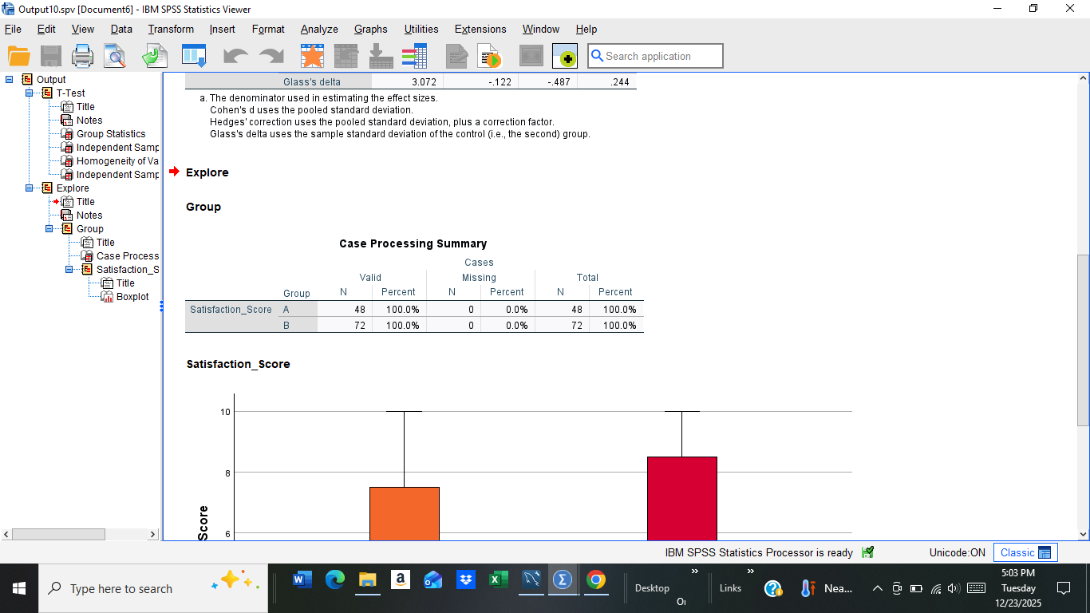
- The average satisfaction scores for Group A and Group B were very close in target with each other. The t-test showed there was a small difference but the data was not statistically significant (t(118)=−0.664, p=0.508, p>0.05). Because the p-value is greater than 0.05, I fail to reject the null hypothesis.
- I then graph this data into a boxplot just to show the results as a visual.
